

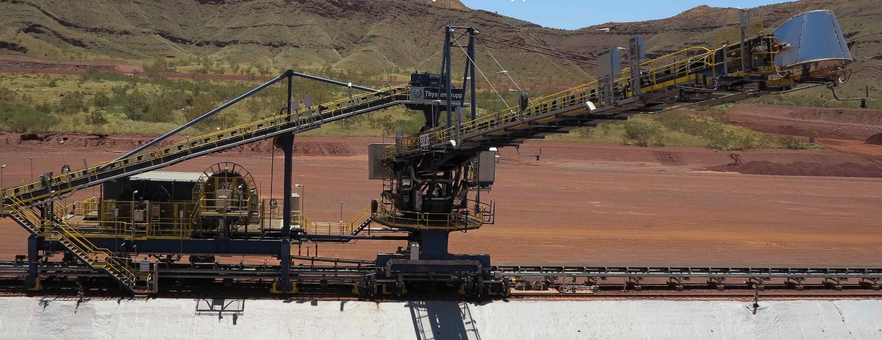

**Solomon Firetail Stacker SK802**

**1 Y MRMP SK802 Inspect Cyclone Preparedness**

**Work Order: 2200890137**

**Document: BMS-03-REP-061_ICP-MRMP**

**Document Revision**

|  |  |  |  |  |
| --- | --- | --- | --- | --- |
| **Rev** | **Date** | **Prepared** | **Approved** | **Comments** |
| 0 | 30/11/2024 | CN | DR | Client Review |
|  |  |  |  |  |

**Balance Machine Services**

ABN: 18 663 508 576

<https://bmservices.com.au/>

Unit 1, 64 Baile Rd

Canning Vale WA 6155

Contact: [planning@bmservices.com.au](mailto:planning@bmservices.com.au)

**CONTENTS**

1 Job / Scope Description 3

2 Scope of Inspection 3

3 Disclaimers and Limitations 3

4 Inspected Items 3

4.1 Item 1 – Storm Lock Mechanisms & Base plates 3

4.2 Maintenance Cradle Structure & Luff and Slew Tie Downs 4

5 Inspection Results 5

5.1 Defect 1 5

5.2 Defect 2 6

5.3 Defect 3 7

6 Infield Checklist 8

6.1 Solomon Stacker SK802 12 monthly Cyclone Preparedness Inspection Checklist 8

Appendices 11

Appendix 1. Risk Matrix 15

# Job / Scope Description

Balance Machine Services (BMS) were tasked to complete SK802 Cyclone Preparedness Inspections during the recent FT24OP11 Firetail shutdown at Solomon.

# Scope of Inspection

The MRMP procedure & associated checklist provide FMG with the information required to perform Cyclone Preparedness Inspections on Solomon Stacker SK802. The 12 monthly cyclone preparedness inspection checklist **(SO-08008-CK-ST-0012)** is to be used in conjunction with Solomon Stacker SK802 12 monthly Cyclone Preparedness Inspection procedure (**SO-08008-PR-ST-0012**).

The inspection is to be carried out by a competent Mechanical Inspector and will take 6 hours to complete.

The primary objective of this work is to enable reporting on the cyclone tie down and storm lock condition and serviceability, noting any defects and corrective actions that may be required to prolong the life span of this equipment.

# Disclaimers and Limitations

BMS inspections were completed as per FMG MRMP – Solomon Stacker SK802 12 monthly Cyclone Preparedness Inspection Checklist SO-08008-CK-ST-0012.

The scope of supply and services for machine inspections is limited only to a visual inspection of the Long Travel storm lock mechanisms, Maintenance cradle, Slew & Luff cyclone restraint components of the plant / machine being the subject of this report. In performing a visual inspection, it is not possible to identify all defects in the components and steel structures.

Some (but not all) of the factors limiting the effectiveness of the inspection are: Defects could develop in non-visible areas of the plant / machine.

Defects could be covered by paint, dust, dirt, material build up, lubricants or a combination thereof.

Some defects may not have propagated to the surface of the relevant component and may therefore not be visible.

In light of the above, BMS offer no warranty or indemnity whatsoever to the client that the inspection will result in the detection or identification of all or any existing or possible defects in the inspected plant/machine.

# Inspected Items

## Item 1 – Storm Lock Mechanisms & Base plates

## Maintenance Cradle Structure & Luff and Slew Tie Downs

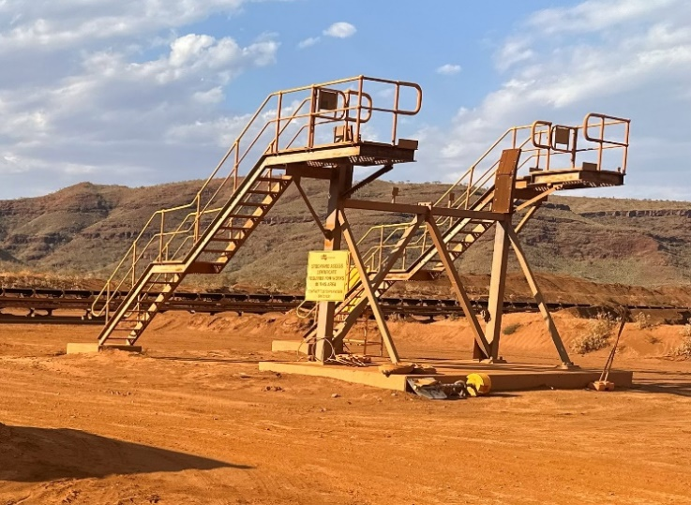

# Inspection Results

1. Long Travel Storm Lock Base plate – Damaged Grouting – West Side (Outer)
2. Long Travel Storm Lock Base plate – Damaged Grouting – West Side (Outer)
3. Maintenance Cradle Structure - Luff Proxy Brackets added – Paint Damage

## Defect 1

|  |  |  |  |  |  |  |  |  |  |  |  |
| --- | --- | --- | --- | --- | --- | --- | --- | --- | --- | --- | --- |
| **Defect Reference & Location** | | | | | | **SAP Equipment Identification** | | | | | |
| **Inspection Date:** | 9/11/2024 | | | | | **FLOC:** | | Planner use if not known | | | |
| **Defect Title:** | Long Travel Storm Lock Base Plate Grouting Damaged | | | | | **Equip:** | | Planner use if not known | | | |
| **WO Ref:** | 2200890137 | | | | | **Assy:** | | Planner use if not known | | | |
| **Defect ID:** |  | | | | | **Equip / Tag Number:** | |  | | | |
| **Defect Location Description:** | SK802 Long Travel Storm Lock Base Plate East Side Outer (Southeast Side) | | | | | | | | | | |
|
|  | | | | |  | | | | | | |
| **Defect Description** | | | | | | | | | | | |
| Storm Lock Base Plate Grouting has been damaged / Chipped on outer corner. | | | | | | | | | | | |
| **Defect Risk Assessment (See Risk Matrix)** | | | | **Attachments Incl:** | | |  | | **Number of Pages:** | |  |
| **Failure Probability:** | | 1/100 year | | **SAP Cause Code:** | | |  | | | | |
| **Potential Consequence:** | | Minor | | **SAP Damage Code:** | | |  | | | | |
| **Risk Rating:** | | **1** | | **SAP Priority Code:** | | |  | | | | |
| **Defect Repair Requirements** | | | | | | | | | | | |
| 1. 1 hr to prepare paperwork. 2. Installation of 2 x locks 3. 1 x mechanical trade, 4. Grout, trowel, shovel, Hammer & Chisel, small brush & (to remove loose materials). 5. PPE as required – Double eye protection, gloves, P2 Dust masks | | | | | | | | | | | |
| **Repair Operational Status:** | | |  | | | **Scaff / EWP Required:** | | | | No | |
| **Repair Duration Estimate (hours):** | | | **4 Hrs** | | | **Crane Required:** | | | | No | |
| **Repair Labour Type:** | | | 1x Trades | | | **Special Tooling / Parts:** | | | | No | |

## Defect 2

|  |  |  |  |  |  |  |  |  |  |  |  |
| --- | --- | --- | --- | --- | --- | --- | --- | --- | --- | --- | --- |
| **Defect Reference & Location** | | | | | | **SAP Equipment Identification** | | | | | |
| **Inspection Date:** | 2/10/2024 | | | | | **FLOC:** | | Planner use if not known | | | |
| **Defect Title:** | Long Travel Storm Lock Base Plate Grouting Damaged | | | | | **Equip:** | | Planner use if not known | | | |
| **WO Ref:** | 2200890137 | | | | | **Assy:** | | Planner use if not known | | | |
| **Defect ID:** |  | | | | | **Equip / Tag Number:** | |  | | | |
| **Defect Location Description:** | SK802 Long Travel Storm Lock Base Plate West Side Outer (Northwest Side) | | | | | | | | | | |
|
|  | | | | |  | | | | | | |
| **Defect Description** | | | | | | | | | | | |
| Storm Lock Base Plate Grouting has been damaged / Chipped on Both outer corners. | | | | | | | | | | | |
| **Defect Risk Assessment (See Risk Matrix)** | | | | **Attachments Incl:** | | |  | | **Number of Pages:** | |  |
| **Failure Probability:** | | 1/100 year | | **SAP Cause Code:** | | |  | | | | |
| **Potential Consequence:** | | Minor | | **SAP Damage Code:** | | |  | | | | |
| **Risk Rating:** | | **1** | | **SAP Priority Code:** | | |  | | | | |
| **Defect Repair Requirements** | | | | | | | | | | | |
| 1. 1 hr to prepare paperwork. 2. Installation of 2 x locks 3. 1 x mechanical trade, 4. Grout, trowel, shovel, Hammer & Chisel, small brush & (to remove loose materials). 5. PPE as required – Double eye protection, gloves, P2 Dust masks | | | | | | | | | | | |
| **Repair Operational Status:** | | |  | | | **Scaff / EWP Required:** | | | | No | |
| **Repair Duration Estimate (hours):** | | | **5 Hrs** | | | **Crane Required:** | | | | No | |
| **Repair Labour Type:** | | | 1x Trades | | | **Special Tooling / Parts:** | | | | No | |

## Defect 3

|  |  |  |  |  |  |  |  |  |  |  |  |
| --- | --- | --- | --- | --- | --- | --- | --- | --- | --- | --- | --- |
| **Defect Reference & Location** | | | | | | **SAP Equipment Identification** | | | | | |
| **Inspection Date:** | 9/11/2024 | | | | | **FLOC:** | | Planner use if not known | | | |
| **Defect Title:** | Paint Damage on Main Upper SHS Cross Supports | | | | | **Equip:** | | Planner use if not known | | | |
| **WO Ref:** | 2200890137 | | | | | **Assy:** | | Planner use if not known | | | |
| **Defect ID:** |  | | | | | **Equip / Tag Number:** | |  | | | |
| **Defect Location Description:** | SK802 Maintenance Cradle – Upper SHS Cross Support Beam (Highlighted Red circles) | | | | | | | | | | |
|
|  | | | | |  | | | | | | |
| **Defect Description** | | | | | | | | | | | |
| Maintenance cradle – Signs of surface corrosion on Main upper SHS Cross support where 2x Unistrut brackets have been welded on top for Luff proxy Sensors under the Boom. To prevent further corrosion developing in these areas (circled in Red), mechanically remove damaged paint surfaces and repaint as per FMG protective coating specifications ( Red).  Areas of minor surface corrosion also visible on SHS Diagonal & Side Supports which could also be cleaned up & repainted at the same time (Green circles). | | | | | | | | | | | |
| **Defect Risk Assessment (See Risk Matrix)** | | | | **Attachments Incl:** | | |  | | **Number of Pages:** | |  |
| **Failure Probability:** | | 1/10 year | | **SAP Cause Code:** | | |  | | | | |
| **Potential Consequence:** | | Medium | | **SAP Damage Code:** | | |  | | | | |
| **Risk Rating:** | | **2** | | **SAP Priority Code:** | | |  | | | | |
| **Defect Repair Requirements** | | | | | | | | | | | |
| 1. 1 hr to prepare paperwork. (PTW to include Hot Work & Working at Heights certificate) 2. Installation of 2 x locks 3. 1 x mechanical trade, 1x trade assistant (EWP Spotter) 4. Grinder & Paint removal discs, 4L Paint, Paint & Small Paint Rollers(100mm wide) ,Small Paint roller Trays or 1L buckets, tetra radio 5. PPE as required – Double eye protection, P2 Dust masks, leather gloves (for grinding) 6. Paint as per FMG protective coating specifications | | | | | | | | | | | |
| **Repair Operational Status:** | | |  | | | **Scaff / EWP Required:** | | | | Yes - EWP | |
| **Repair Duration Estimate (hours):** | | | **12 Hrs** | | | **Crane Required:** | | | | No | |
| **Repair Labour Type:** | | | 1x Trade  1x TA (EWP Spotter | | | **Special Tooling / Parts:** | | | | Yes - Paint | |

# Infield Checklist

## Solomon Stacker SK802 12 monthly Cyclone Preparedness Inspection Checklist

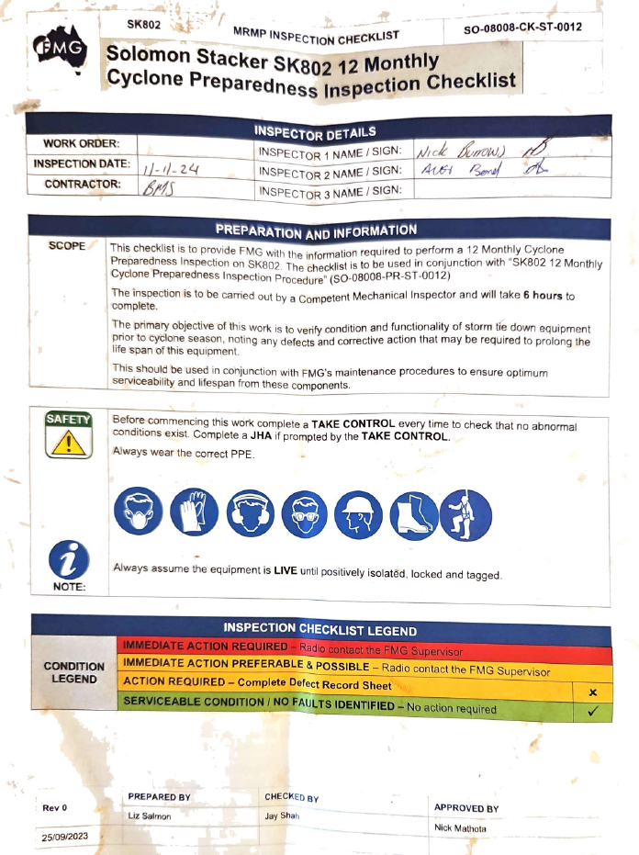

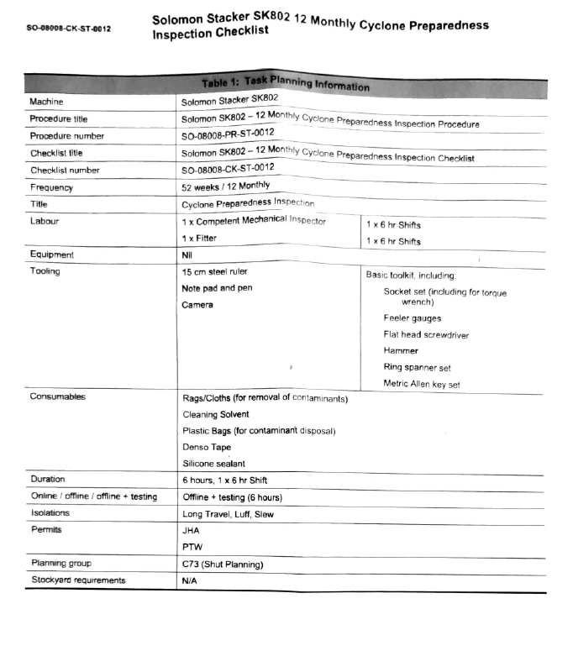

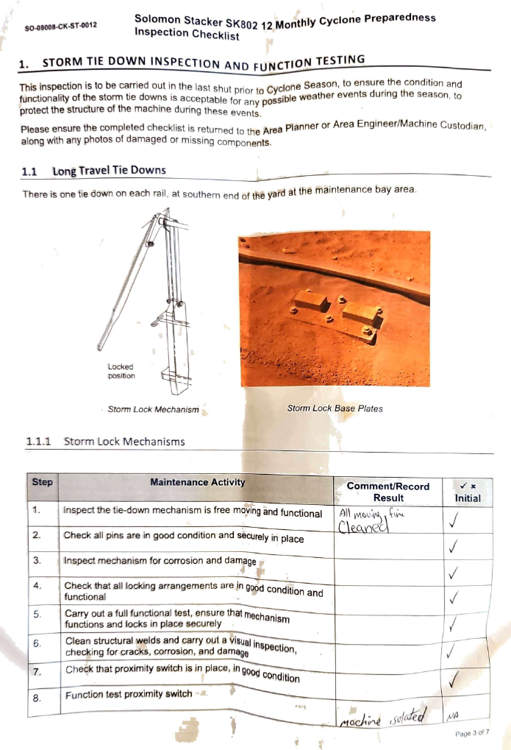

# Appendices

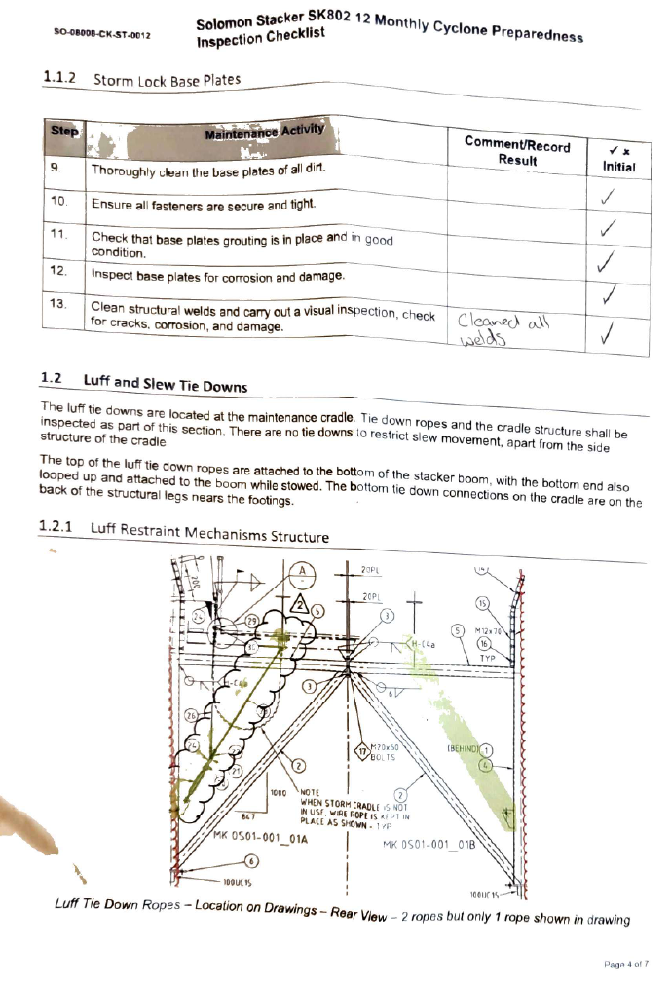

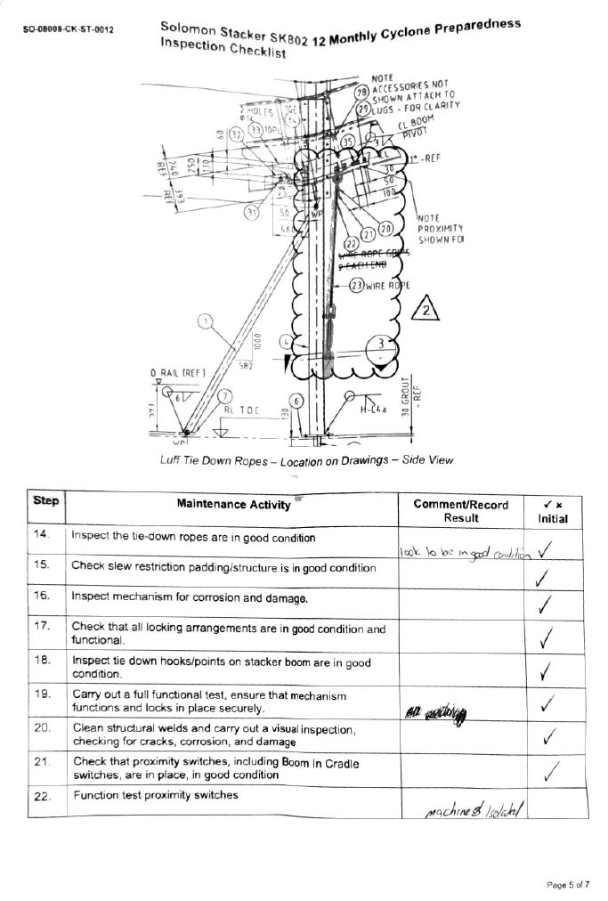

#### Risk Matrix

Table -- Risk Matrix

|  |  |  |  |  |  |  |  |
| --- | --- | --- | --- | --- | --- | --- | --- |
|  | | | **Consequence** | | | | |
| **1 - Minor** | **2 - Medium** | **3 - Serious** | **4 - Major** | **5 - Extreme** |
| **Probability** | **Risk Frequency** | **Risk Descriptor** | **FAI $10k - $100k** | **MTI $100k - $500k** | **RWI $500k - $2M** | **LTI $2M - $20M** | **Fatality > $20M** |
| 1/week | A - Almost Certain | Moderate | High | Extreme | Extreme | Extreme |
| 1/month | B - Likely | Moderate | High | High | Extreme | Extreme |
| 1/year | C - Possible | Low | Moderate | High | High | Extreme |
| 1/10 years | D - Unlikely | Low | Low | Moderate | High | High |
| 1/100 years | E - Rare | Low | Low | Low | Moderate | High |

FAI - First Aid Injury: An injury that requires basic first aid treatment, usually minor and not requiring medical intervention.

MTI - Medical Treatment Injury: An injury that requires medical treatment beyond first aid but is not life-threatening.

RWI - Restricted Work Injury: An injury that results in the employee being unable to perform their normal work duties for a period of time,

but not resulting in a permanent disability.

LTI - Lost Time Injury: An injury that results in an employee being unable to work for at least one full shift or day.